Method Statement

Elevator Installation

01-Jan-23

**OTIS ELEVATOR COMPANY INDIA LIMITED**

Table of contents

1 STATUS 2

2 REVISION HISTORY 2

3 INTRODUCTION 3

3.1 SAFETY 3

3.2 QUALITY 3

3.3 PURPOSE 3

3.4 SCOPE 3

3.5 REFERENCES 3

4 RESPONSIBILITY 3

5 INSTALLATION PROCESS / WORK SEQUENCE 4

5.1 PRIORITY LIFTS 4

5.2 PRE-REQUISITES 4

5.3 SCAFFOLD ERECTION AND “WORKS BY OTHERS” 4

5.4 PLUMBING THE HOIST-WAY 5

5.5 BRACKET FIXING AND GUIDE RAILS INSTALLATION 5

5.6 PIT EQUIPMENTS 6

5.7 LANDING DOORS 7

5.8 DOOR FRAME GAPS FILLING 8

5.9 LMR EQUIPMENT INSTALLATION 8

5.10 CAR & COUNTERWEIGHT 9

5.11 ROPES 9

5.12 HOISTWAY CONDUIT AND WIRING 10

5.13 STARTING AND ADJUSTING, TESTING and COMMISSIONING 11

5.14 HANDING OVER 12

# STATUS

(Box for status stamp & comments)

|  |
| --- |
|  |

# REVISION HISTORY

|  |  |  |  |  |
| --- | --- | --- | --- | --- |
| **Date of issue** | **Description** | **Action** | **Status** | **By** |
|  |  |  |  |  |
|  |  |  |  |  |
|  |  |  |  |  |
|  |  |  |  |  |
|  |  |  |  |  |

# INTRODUCTION

## SAFETY

The primary safety documents governing this method statement are the Project safety plan and the client’s Safety management system which includes Otis’ Worldwide Job-Site Safety System (WJSSS)

## QUALITY

The Otis Quality Plan governs the in-process installation inspections, completion and handover procedures.

For the purposes of this method statement, sequence of installation of the elevator is classified into different standard work procedures as below.

## PURPOSE

The purpose of this method statement is to define the procedure to be followed for the complete installation of traction elevators at MN3600 Project.

## SCOPE

This method refers to various work procedures which explain the sequential method and covers the installation of the traction elevators.

## REFERENCES

1. Technical Specifications
2. WWJSSS, Otis World-Wide Job-Site Safety Standards
3. Otis Elevators Installation Manual

# RESPONSIBILITY

The elevators will be installed under the supervision of the OTIS Construction executive. All OTIS employees and OTIS sub-contractors are responsible for Project Safety. OTIS Project Safety is implemented via the onsite Construction executive and assisted by area safety supervisor.

OTIS Site Engineers / Supervisors will be directly responsible for verifying completed works to ensure quality standards are maintained throughout the project. The OTIS QA/QC engineer shall monitor all works and verify quality standards are met.

The Project Manager shall be directly responsible to ensure that proper Safety standards are implemented and maintained throughout construction. Likewise, the Project Manager will be directly responsible to ensure quality standards are maintained throughout the project.

# INSTALLATION PROCESS / WORK SEQUENCE

## PRIORITY LIFTS

As per the local authority requirements, the priority lifts shall be Service lifts in each tower. The works shall be executed according to the agreed schedule.

## PRE-REQUISITES

1. The lift shaft shall be ready as per the dimensions shown in the approved drawings.
2. Lift shaft entrance walls (block walls) shall be constructed including plastering leaving the rough door openings as per the drawings.
3. Survey lines & FFL markings to be provided at all levels.
4. Machine room block works including plastering, painting, ventilation grills to be ready.
5. Temporary illumination in lift shaft and LMR for preparatory works.
6. Temporary lighting in the general areas adjacent as specified is required.
7. Temporary storage area preferably in the ground level near the lift shafts.
8. Elevator shaft pits to be waterproofed, clean and dry. Protected against water ingress.

## SCAFFOLD ERECTION AND “WORKS BY OTHERS”

Upon readiness of the lift shafts as mentioned above. Steel scaffolding will be installed in the lift shafts sequentially as per the site conditions & shaft handovers. Later the shafts along with scaffolding shall be complete to start installation activities. Below sketch shows few guidelines followed by OTIS for scaffolding.

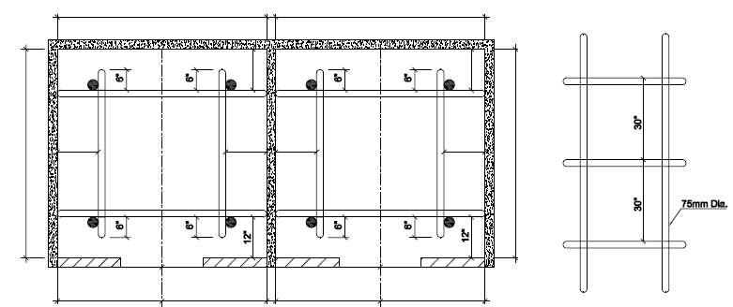

## PLUMBING THE HOIST-WAY

Plumbing the hoist-way means dropping plumb lines to check that the elevator will have sufficient clearance throughout the entire rise and to locate the position of the car guide rails. In order to locate the hoist-way and the position of the guide rails, the contractor provides a “Survey grid lines”, usually the centerline of a building column, from which all other measurements can be made. The layout drawing provides all the necessary measurements to locate the clear hoist-way and the car guide rails from the “reference point”. Two critical measurements made from the “reference point” are:

1. The front-to-rear distance to the center line of the car guide rails.
2. The side-to-side (post wise) distance to the face of a rail blade.

Another critical measurement is the DBG (distance-between-guide rails). Once the location of the car guide rails has been established, the location of all other elevator equipment can be determined. The plumb lines that locate the position of the guide rails are dropped to a reference floor, usually the first landing. In theory, the plumb lines locating the car guide rails are usually centered between the building walls or steel to which the rail brackets are fastened and set back from the hoistway entrance so that the DGB line is the specified distance from and parallel to the landing sill line. In actual practice, some juggling (averaging) may be required if there are variations in the location of the landing sill line from floor-to-floor.

## BRACKET FIXING AND GUIDE RAILS INSTALLATION

Rail brackets are anchored to c channel. Then the pit channels are fixed. First set of are pulled into the hoistway and positioned on pit channel. The rails are locked with brackets using rail clips. The rails are aligned using rail alignment gauge and tighten the bolts with proper shims. The activity is repeated until all the guide rails are installed in the hoistway. The rails are hoisted using the electric winch.

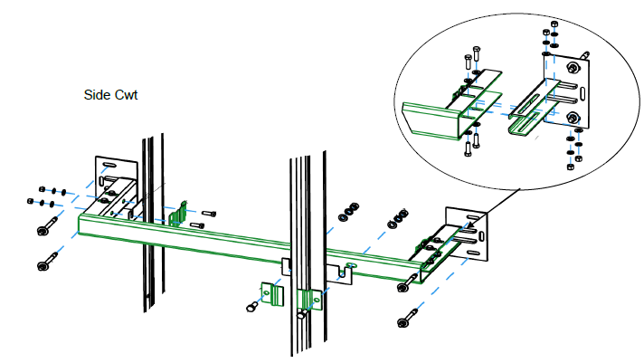

## PIT EQUIPMENTS

The pit equipment can be installed anytime after rails have been installed and aligned but must be installed before the car frame can be built. All pit equipment will be lowered into the pit by electric chain block or winch which is attached to the pit installation beam at nearest level .The material will be installed from the lowest landing served for all groups of lift. Pit ladder and accessories will be installed.

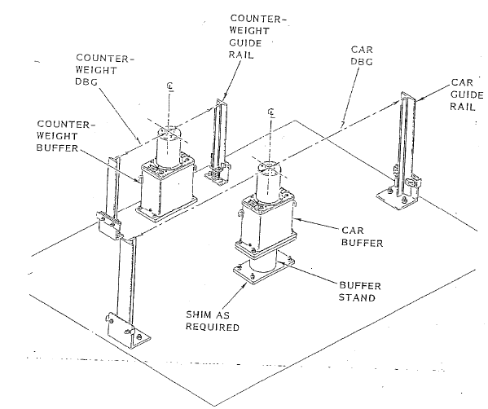

## LANDING DOORS

Installing all passenger elevator entrances including sill, sill support angles, header, fascias, hangers and hanging doors. Installing door closers, interlocks and all hoistway and wiring required in this section.

Prior to the entrance installation the survey datum lines should be set adjacent to the lift hoistway. The entrance door boxes will have to be shifted to each floor level. Otis will install the sill at the finished floor level supplied by the surveyor or by others. The sills are anchored to the floor slab with anchor bolts.

The door frames fitted and aligned. The hoistway doors hanged and the door locks can be adjusted to remain in the closed position. The temporary entrance protection can now be removed.



There will be a gap between landing entrance frames and the raw block wall around the landing door openings. The gaps must be sealed using cement motor or suitable masonry as per civil contractor’s choice without disturbing the alignment of the entrance frames at all floors.

Note: Clear written communication must be established before permitting other agency workers in to the lift shafts by OTIS supervisor & Customer’s representative.

## DOOR FRAME GAPS FILLING

The gaps between door frames and the raw entrance walls need to be filled up “by others” whilst close co-ordination with OTIS team. Other agency workers to follow proper safety procedures while executing the work. During this activity OTIS personals should not enter the lift shaft/pit considering safety precautions.

## MRL EQUIPMENT INSTALLATION

The machine must be aligned both front to rear and side to side (Post wise) so that the rope drop from the drive sheave is in line with car hitch. The beams are set into position, using the dimensions obtained from the layout drawing, marked and drilled for final location. The machine is moved by manpower to the respective location in the correct sequence determined by the Lift contractor. The machine is located to machine bed

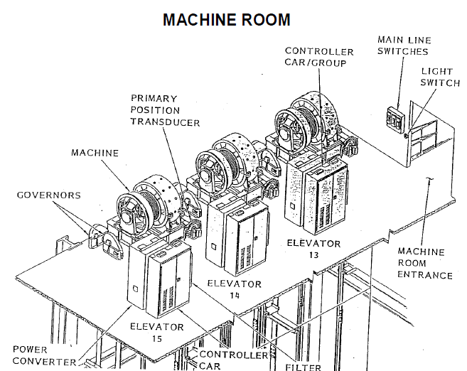

## CAR & COUNTERWEIGHT

The car frame will be installed at the lowest level served by the car. All material will be shifted manually from the store to the respective floors in the building. The installation of the car frame will be done. The car frame safety plank is placed on props in the pit and adjusted to be level. The side channels are installed and the bolts are loose. The top plank is now fitted and the diagonal distances are now measured to be equal, the car frame bolts are now tightened. The car cradle and platform are now installed and aligned. The side braces are now fitted and adjusted to the correct location.

On completion of the car frame, the safety blocks, roller guides, lift rods are fitted, followed by the installation of the car enclosure, car doors and door operators. The counterweight frame will be installed at the top landing served by the lift, it will be installed by chain block supported from the machine room level. Roller guides and safety gear will be attached.

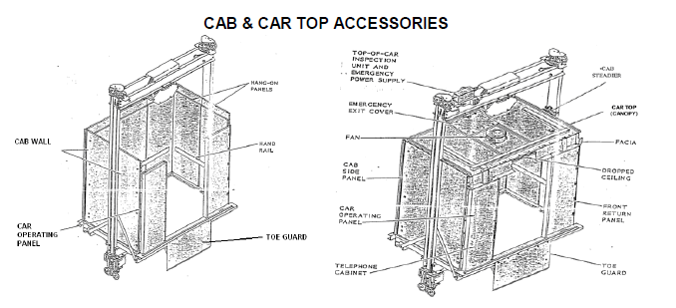

## ROPES

Rope hitch will be installed adjacent to the machine, then belt will be fixed and tightened to the rope hitch. The rope will passing through CWT sheave fixed at the top of CWT, then machine sheave then car sheave fixed at the top of the car, the other end of the rope will be fixed with rope hitch installed opposite side of machine.

The governor rope is also installed at the same time. On completion of the roping the cwt frame is lowered on the ropes. With the aid of the scaffolding & platforms and a winch, the cwt is filled with the filler weights until it is approx 10% heavier than the car frame. At this point the machine brake is mechanically released and allows the cwt to slide down the rail by approx one meter. The car frames support steel can now be removed from the lift shaft. The car and counterweight are now supported by the main hoist ropes. Once the power is connected to the motor and the Otis wiring completed the lift is ready for a shaft inspection run. The car will reach the top floor and the counterweight will be at the pit level.



## HOISTWAY CONDUIT AND WIRING

Shaft harness cables, travelling cables, along with cable hangers done inside the lift shaft and landing doors electric contact wiring done along with the junction box for harness cable, cable hanger, messenger wire and pit switch.





## STARTING AND ADJUSTING, TESTING and COMMISSIONING

The Otis adjuster adjusts, tests and fine-tunes the newly constructed elevator so that it works to its peak performance. The tested adjusted elevator shall satisfy the safety requirements of the state/local codes and also as per the technical performance specifications.

Prior commissioning of the elevator, erectors run the elevator only at inspection speed, using the temporary run box or top-of car controls. Erectors make sure that:

1. All wiring is completed.

2. All hardware is installed, cleaned, painted and lubricated.

3. The pit, hoistway and machine room have been inspected for obstructions or defects that could prevent safe operations of the car within the hoistway.

OTIS Adjuster performs most of the adjustments and does all the elevator test runs at contract load and speed. The adjuster performs the following activities:

1. Balance car/counterweight.

2. Adjusts roller guides.

3. Adjusts door operator.

4. Adjusts door detector.

5. Adjusts door locks.

6. Adjusts brake.

7. Adjusts governor.

8. Checks signal equipment.

9. Checks hoistway position reader.

10. Checks limit switches.

11. Completes Group Operation testing

11. Commissions and test all ancillary devices

12. Carries out all interface testing with other trades

13. Completes internal and external punch lists

At the completion of the above works the adjuster completes the Inspection and Test documentation and the company “Field test and data report form” which is retained on file. Copies of all contractual close-out documentation will be provided.

## HANDING OVER

The final act preceding formal handover of the elevators is the OTIS internal transfer to maintenance. Upon successful completion of each units pro rata basis will be inspected by Otis maintenance team and taken over into the Otis maintenance portfolio. As per agreed procedure the commercial closing of the units are initiated. The elevator is handed over to the OTIS maintenance team for further routine preventive maintenance per schedule.